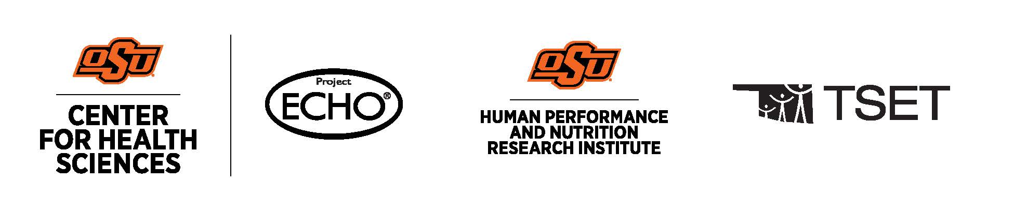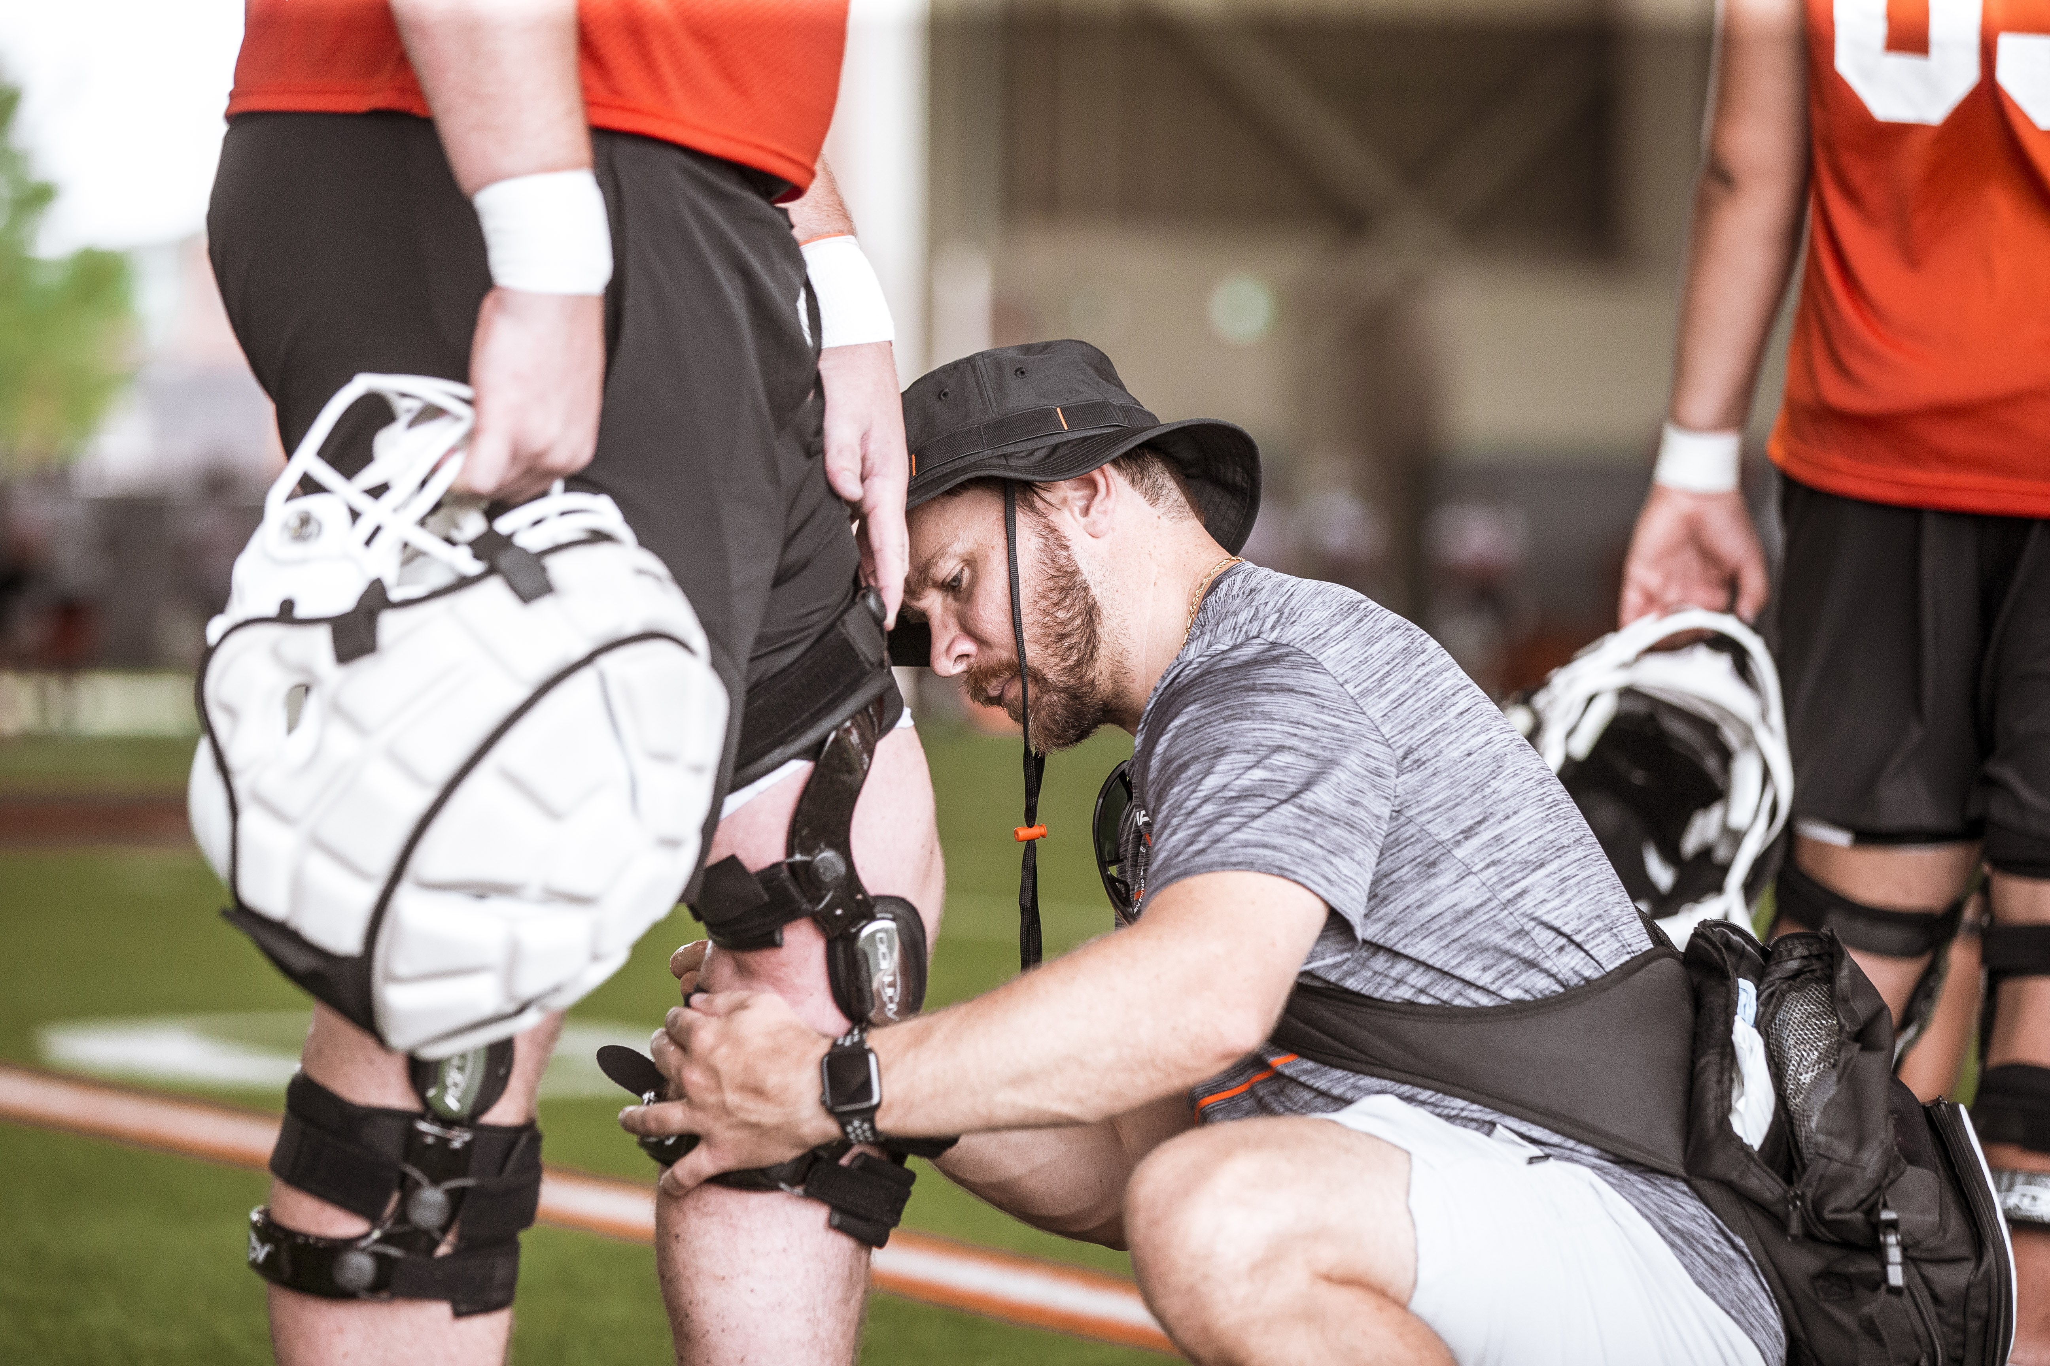  Spineboarding: Spinal Motion Restriction Vs. Immobilization  Learning Objectives  -Discuss the differences between spinal motion restriction (SMR) and spinal immobilization (SI)  -Identify when to utilize SMR/SI in cervical spine patients  -Discuss specific techniques for spinal motion restriction  Schedule and Format  - Wednesday, November 12, 2025; 12-1:00pm  Cancellation/Refund Policy  - None. No payments necessary.  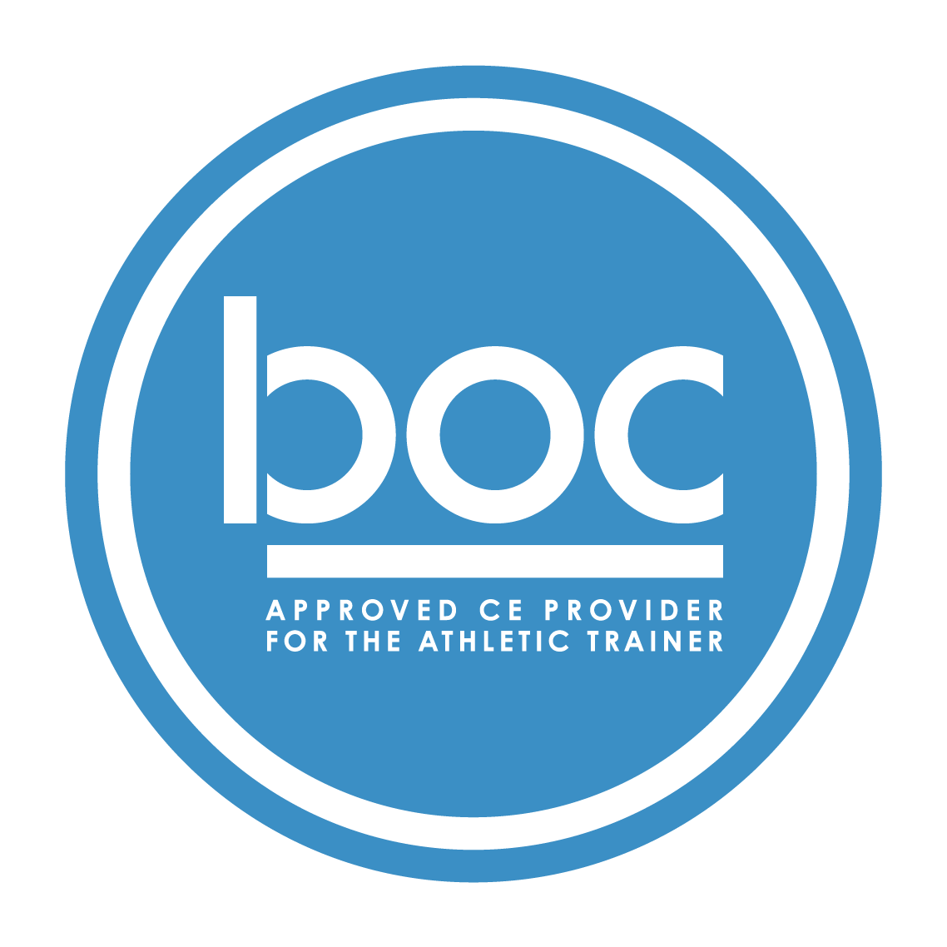  Oklahoma State University Center for Health Sciences Office of Continuing Education (BOC AP#: P12117) is approved by the Board of Certification, Inc. to provide continuing education to Athletic Trainers (ATs). This program is eligible for a maximum of (1.00) Category A hours/CEUs. ATs should claim only those hours actually spent in the educational program.
  Jennifer Volberding, PhD, LAT, ATC
  ____
  NO REQUIRED MATERIALS OR EQUIPMENT
  ____
  1-HOUR CATEGORY A CEU AVAILABLE
  ____
  TSET Grant
  NO FEES
  ____
  SESSIONS ARE VIRTUAL VIA ZOOM
  OSU CENTER FOR HEALTH SCIENCES
  1111 W 17th St
  Tulsa, OK 74107
  918-561-8255
  Register:
  https://redcap.okstate.edu/surveys/?s=3KY39MLMMHKCCHMY
  Website
  https://medicine.okstate.edu/echo/atsm-echo.html

